./

GENESIS –Advanced Python Programming



|  |  |  |  |  |  |
| --- | --- | --- | --- | --- | --- |
| **Ver. Rel. No.** | **Release Date** | **Prepared. By** | **Reviewed By** | **To be Approved** | **Remarks/Revision Details** |
| 01 |  | Arjun Joshy |  |  |  |
|  |  |  |  |  |  |
|  |  |  |  |  |  |
|  |  |  |  |  |  |
|  |  |  |  |  |  |

**Details**

Contents 3

Day-1 4

Implementation using functions. 4

Code: 4

Pep8 Screenshot: 8

GIT Link: 8

Day-2 9

Implementation Using OOPS Concepts 9

Code: 9

Pep8 Screenshot: 12

GIT Link: 12

Final Submission 13

Added File handling and additional features: 13

Code: 13

Pep8 Screenshot: 17

Git Link: 18

# Day-1

# Implementation using functions.

### Code:

|  |
| --- |
| global f |
|  | f = 0 |
|  | # this name_movie function is used to see movie name |
|  |  |
|  |  |
|  | def cost(ticket): |
|  | pass |
|  |  |
|  |  |
|  | def m_name(): |
|  | global f |
|  | f = f + 1 |
|  | print("Which Movie do you want to watch") |
|  | print("1 : The Seven") |
|  | print("2 : Karan Arjun") |
|  | print("3 : Chemmeen") |
|  | print("4 : Back") |
|  | movie = int(input("Choose your movie : ")) |
|  | if movie == 4: |
|  | theatre() |
|  | m_screen_no() |
|  | if f == 1: |
|  | m_screen_no() |
|  | # the screen_no function is used to select screen |
|  |  |
|  |  |
|  | def m_screen_no(): |
|  | print("Which Screen do you want to watch movie: ") |
|  | print("1 : Screen 1") |
|  | print("1 : Screen 2") |
|  | print("3 : Screen 3") |
|  | a = int(input("Choose your screen : ")) |
|  | ticket = int(input("Number of tickets you want :")) |
|  | cost(ticket) |
|  | m_timing(a) |
|  | # the timing function is used to select timing for the movie |
|  |  |
|  |  |
|  | def m_timing(a): |
|  | time1 = { |
|  | "1": "10.00 A.M.", |
|  | "2": "01.10 P.M.", |
|  | "3": "04:20 P.M.", |
|  | "4": "07:30 P.M. " |
|  | } |
|  | time2 = { |
|  | "1": "10.15 A.M.", |
|  | "2": "01.25 P.M.", |
|  | "3": "04:35 P.M.", |
|  | "4": "07:45 P.M. " |
|  |  |
|  | } |
|  | time3 = { |
|  | "1": "10.30 A.M.", |
|  | "2": "01.40 P.M.", |
|  | "3": "04:50 P.M.", |
|  | "4": "07:30 P.M." |
|  | } |
|  | if a == 1: |
|  | print("Choose your time: ") |
|  | print(time1) |
|  | t = input("Select your time :") |
|  | x = time1[t] |
|  | print("Booking Confirmed , Enjoy your movie at :" + x) |
|  | elif a == 2: |
|  | print("choose your time :") |
|  | print(time2) |
|  | t = input("Select yout time :") |
|  | x = time2[t] |
|  | print("Booking Confirmed , Enjoy your movie at :" + x) |
|  | elif a == 3: |
|  | print("Choose your time :") |
|  | print(time3) |
|  | t = input("Select yout time :") |
|  | x = time3[t] |
|  | print("Booking Confirmed Enjoy your movie at :" + x) |
|  |  |
|  |  |
|  | def movie(m_screen_no): |
|  | if m_screen_no == 1: |
|  | m_name() |
|  | elif m_screen_no == 2: |
|  | m_name() |
|  | elif m_screen_no == 3: |
|  | m_name() |
|  | elif m_screen_no == 4: |
|  | city() |
|  | else: |
|  | print("Invalid Entry") |
|  |  |
|  |  |
|  | def theatre(): |
|  | print("Which theatre do you want to see movie") |
|  | print("1 : INOX") |
|  | print("2 : IMAX") |
|  | print("3 : PVR ") |
|  | print("4 : Back") |
|  | a = int(input("Choose your option :")) |
|  | movie(a) |
|  | return 0 |
|  |  |
|  |  |
|  | def city(): |
|  | print("Hi welcome to movie ticket booking") |
|  | print("Where you want to watch movie ?:") |
|  | print("1 : Bangalore ") |
|  | print("2 : Pune ") |
|  | print("3 : Kochi ") |
|  | place = int(input("Choose your option :")) |
|  | if place == 1: |
|  | theatre() |
|  | elif place == 2: |
|  | theatre() |
|  | elif place == 3: |
|  | theatre() |
|  | else: |
|  | print("Wrong Choice") |
|  | city() |

### Pep8 Screenshot:

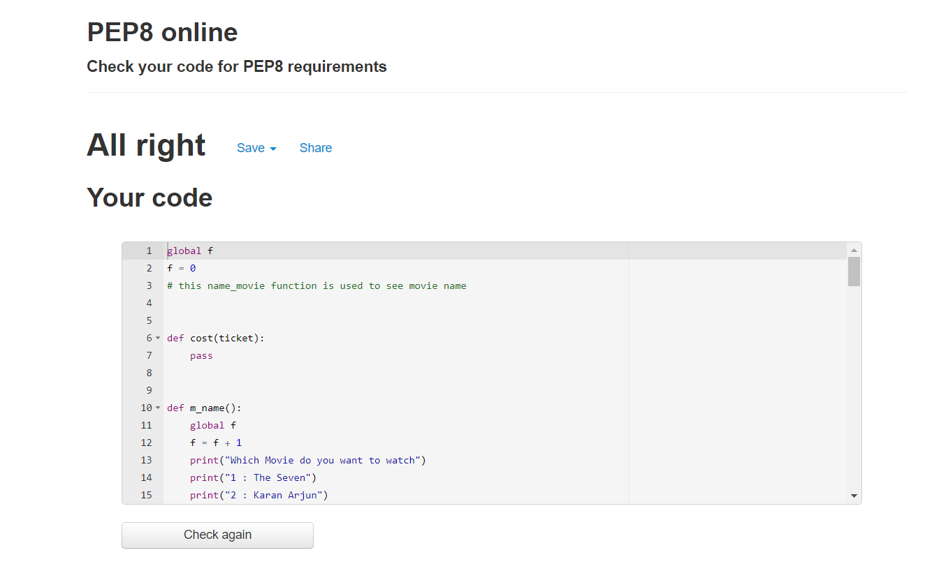

### GIT Link:

<https://github.com/99003202/python_project/blob/main/99003202-Day1.py>

# Day-2

## Implementation Using OOPS Concepts

### Code:

|  |
| --- |
|  |
| import re |
|  | #defining base - class ticket |
|  |  |
|  |  |
|  | class ticket: |
|  | def __init__(self): |
|  | self.ticket_no = 1 |
|  | self.ticket_rate = 120 |
|  |  |
|  | def read_tno(self): |
|  | self.ticket_no = int(input("Enter the number of tickets you need :")) |
|  | self.ticket_rate = (120*(self.ticket_no)) |
|  |  |
|  | def t_show(self): |
|  | print("No: of Tickets :", self.ticket_no) |
|  | print("Total Price :", self.ticket_rate) |
|  |  |
|  | #defining base - class movie |
|  |  |
|  | class movie: |
|  | def __init__(self): |
|  | self.m_pool = ("1. The Seven", "2. Death Race", "3.The Prestige ") |
|  | self.m_screen = ("1.Screen 1", "2.Screen 2", "3.Screen 3 ") |
|  | self.m_timing = ("1. 09:00 A.M.", "2. 03:00 P.M. ", "3. 09:00 P.M. ") |
|  |  |
|  | def m_det(self): |
|  | self.m_no = int(input("Enter the Preferred movie :")) |
|  | if self.m_no == 1: |
|  | self.screen_no = 1 |
|  | self.m_name = "The Seven" |
|  | self.m_time = int(input("Enter the showtime :")) |
|  | elif self.m_no == 2: |
|  | self.screen_no = 2 |
|  | self.m_name = "Death Race" |
|  | self.m_time = int(input("Enter the showtime :")) |
|  | elif self.m_no == 3: |
|  | self.screen_no = 3 |
|  | self.m_name = "The Prestige" |
|  | self.m_time = int(input("Enter the showtime :")) |
|  | else: |
|  | print("Invalid Entry") |
|  |  |
|  | def f_time(self): |
|  | if self.m_time == 1: |
|  | print("Show Time : 09.00 A.M") |
|  | elif self.m_time == 2: |
|  | print("Show Time : 03.00 P.M.") |
|  | elif self.m_time == 3: |
|  | print("Show Time : 09.00 P.M.") |
|  | else: |
|  | print("Invalid Entry") |
|  |  |
|  | def m_show(self): |
|  | print("Movie :", self.m_name) |
|  | print("Screen :", self.screen_no) |
|  | movie.f_time(self) |
|  |  |
|  | #defining class Customer- multiple inheritance from both base classes |
|  | class Customer(ticket, movie): |
|  | def __init__(self): |
|  | self.cust_name = "Default" |
|  | self.cust_no = 91-0000000000 |
|  |  |
|  | def cust_det(self): |
|  | regex = "91-\d{10}" |
|  | self.cust_name = str(input("Enter Your Name :")) |
|  | self.cust_no = str(input("Enter Your 10 digit Phone Number with country code (91-) :")) |
|  | if re.match(regex, self.cust_no): |
|  | print("Valid.") |
|  | ticket.read_tno(self) |
|  | movie.m_det(self) |
|  |  |
|  | def cust_tkt(self): |
|  | print("Name :", self.cust_name) |
|  | print("Phone Number :", self.cust_no) |
|  | movie.m_show(self) |
|  | ticket.t_show(self) |
|  |  |
|  | m1 = movie() |
|  | print(m1.m_pool) |
|  | print (m1.m_timing) |
|  | c1 = Customer() |
|  | c1.cust_det() |
|  | c1.cust_tkt() |
|  |  |

### Pep8 Screenshot:

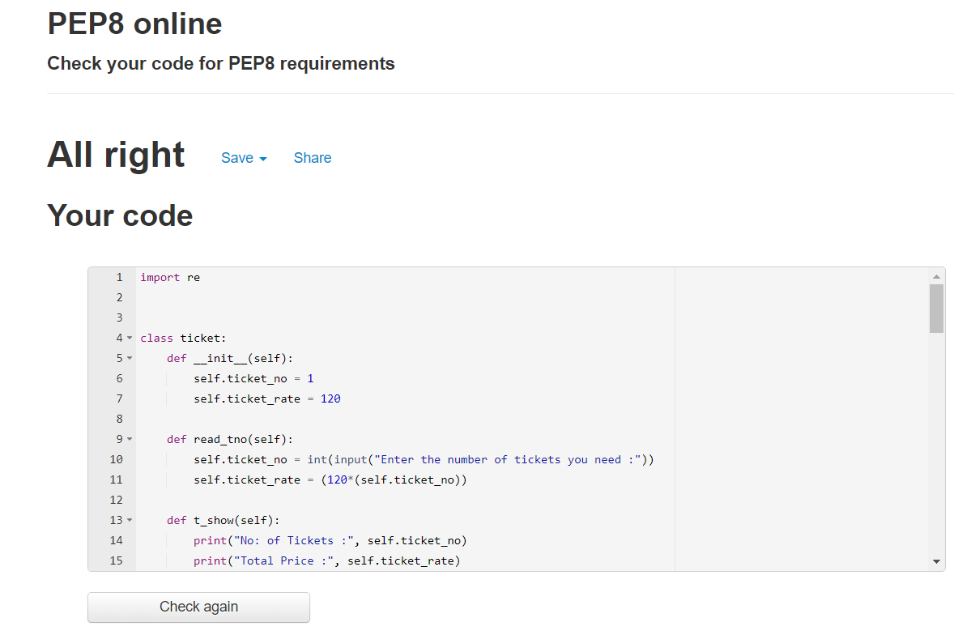

### GIT Link:

<https://github.com/99003202/python_project/blob/main/99003202-Day%202.py>

# Final Submission

## Added File handling and additional features:

### Code:

import re

from datetime import datetime

from datetime import date

import pandas as pd

pd.set_option("Display.max_columns", None)

df = pd.read_csv("movie.csv")

print("-----------------------------------------------")

print("\t\t\tWELCOME TO AJ CINEMAS")

print("-----------------------------------------------\n")

print("\t\tMovies \t \t\t\t\tShow Timings\n")

print("1.Screen 1-", df.Movies[0], "\t \t\t", df.Show_Time[0])

print("2.Screen 2-", df.Movies[1], "\t\t\t", df.Show_Time[1])

print("3.Screen 3-", df.Movies[2], "\t\t", df.Show_Time[2])

class ticket:

def __init__(self):

self.ticket_no = 1

self.ticket_rate = 120

def read_tno(self):

self.ticket_no = int(input("Enter the number of tickets you need :"))

self.ticket_rate = (120*(self.ticket_no))

def t_show(self):

print("No: of Tickets :", self.ticket_no)

print("Total Price :", self.ticket_rate)

class movie:

def __init__(self):

self.m_pool = ("1. The Seven", "2. Death Race", "3.The Prestige ")

self.m_screen = ("1.Screen 1", "2.Screen 2", "3.Screen 3 ")

self.m_timing = ("1. 09:00 A.M.", "2. 03:00 P.M. ", "3. 09:00 P.M. ")

def m_det(self):

self.m_no = int(input("Enter the Preferred movie :"))

if self.m_no == 1:

self.screen_no = 1

self.m_name = "The Seven"

self.m_time = int(input("Enter the showtime :"))

elif self.m_no == 2:

self.screen_no = 2

self.m_name = "Death Race"

self.m_time = int(input("Enter the showtime :"))

elif self.m_no == 3:

self.screen_no = 3

self.m_name = "The Prestige"

self.m_time = int(input("Enter the showtime :"))

else:

print("Invalid Entry")

def f_time(self):

if self.m_time == 1:

print("Show Time : 09.00 A.M")

elif self.m_time == 2:

print("Show Time : 03.00 P.M.")

elif self.m_time == 3:

print("Show Time : 09.00 P.M.")

else:

print("Invalid Entry")

def m_show(self):

print("Movie :", self.m_name)

print("Screen :", self.screen_no)

movie.f_time(self)

class Customer(ticket, movie):

def __init__(self):

self.cust_name = "Default"

self.cust_no = "0000000000"

def cust_det(self):

regex = "91-\d{10}"

self.cust_name = str(input("Enter Your Name :"))

self.cust_no = str(input("Enter Your 10 digit Phone "

"Number with country code(91-): "))

if re.match(regex, self.cust_no):

print("Valid.")

ticket.read_tno(self)

movie.m_det(self)

def cust_tkt(self):

print("***********************\n \t\tTICKET\n***********************")

now = datetime.now()

current_time = now.strftime("%H:%M:%S")

today = date.today()

print(current_time, "\t", today)

print("\nName :", self.cust_name)

print("Phone Number :", self.cust_no)

movie.m_show(self)

ticket.t_show(self)

c1 = Customer()

c1.cust_det()

c1.cust_tkt()

### Pep8 Screenshot:

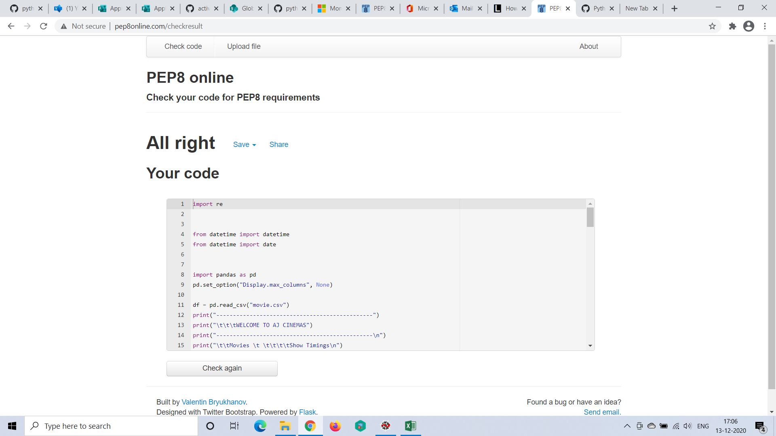

### Git Link:

<https://github.com/99003202/python_project/edit/main/MovieTicket.py>